Amazon S3

1. Console home

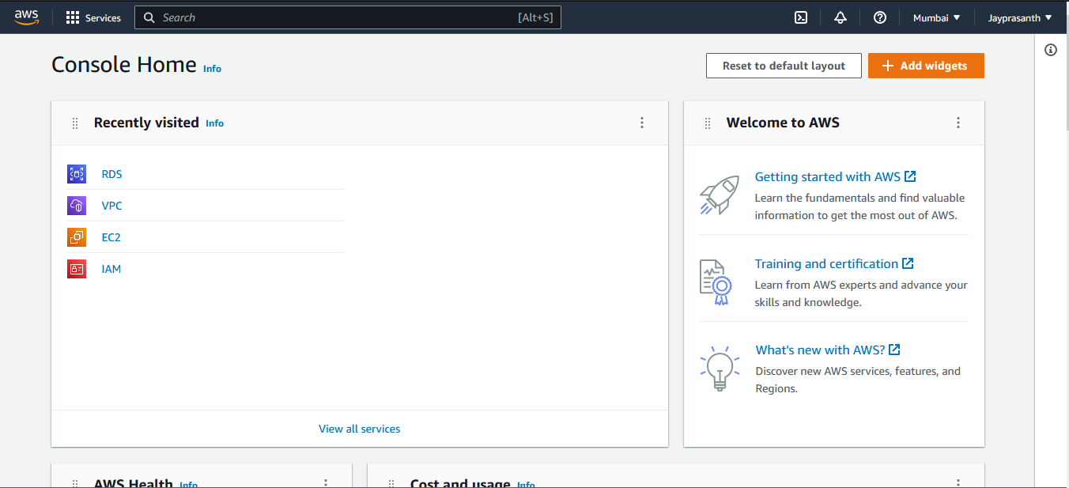

2.Search for S3

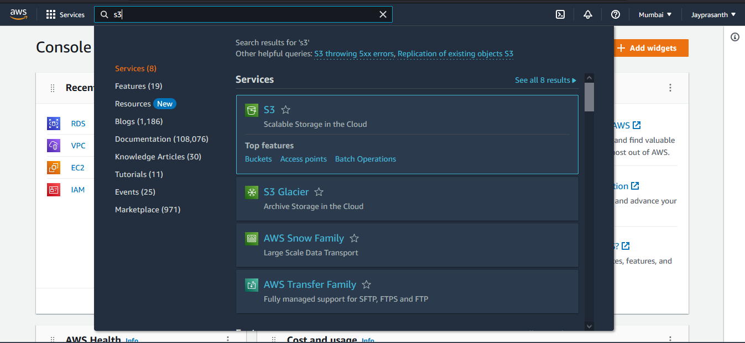

3.S3 page and click Create bucket

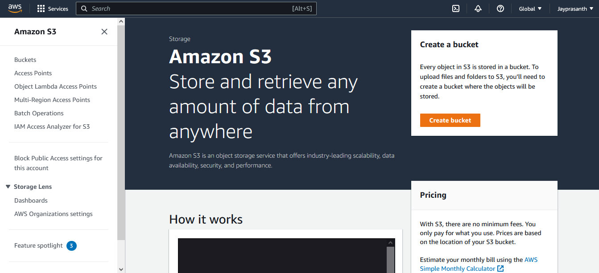

4.S3 create page

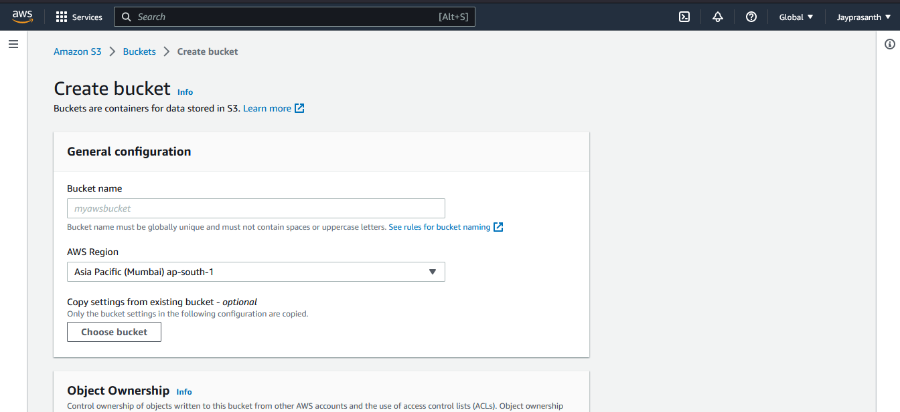

5.Type the name Unique in all

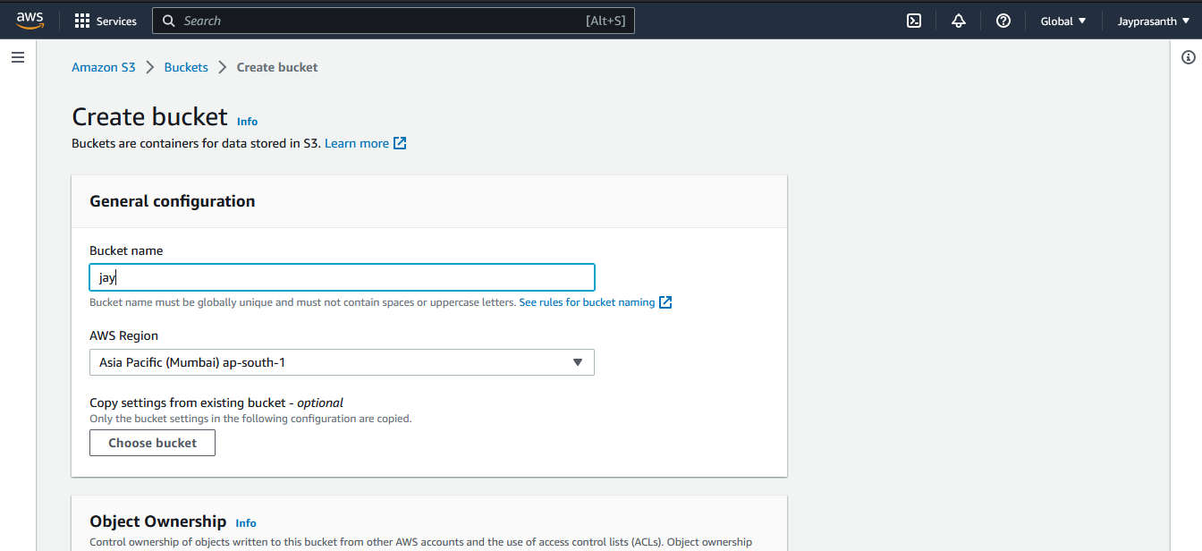

6.choose Object Ownership, I choose ACL disabled

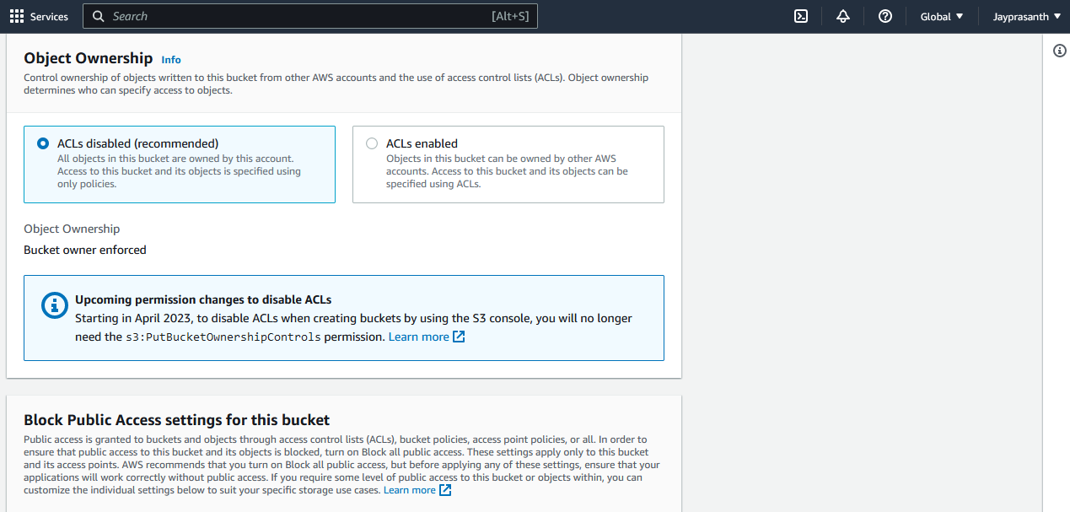

7. Public Access you want to select which option you want

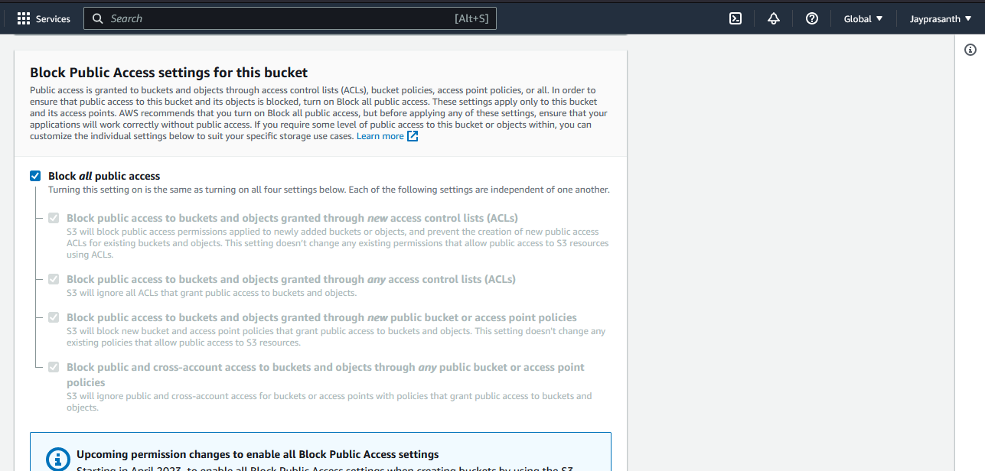

8.Bucket Versioning, versioning is called as Updated data, enable to show the versioning

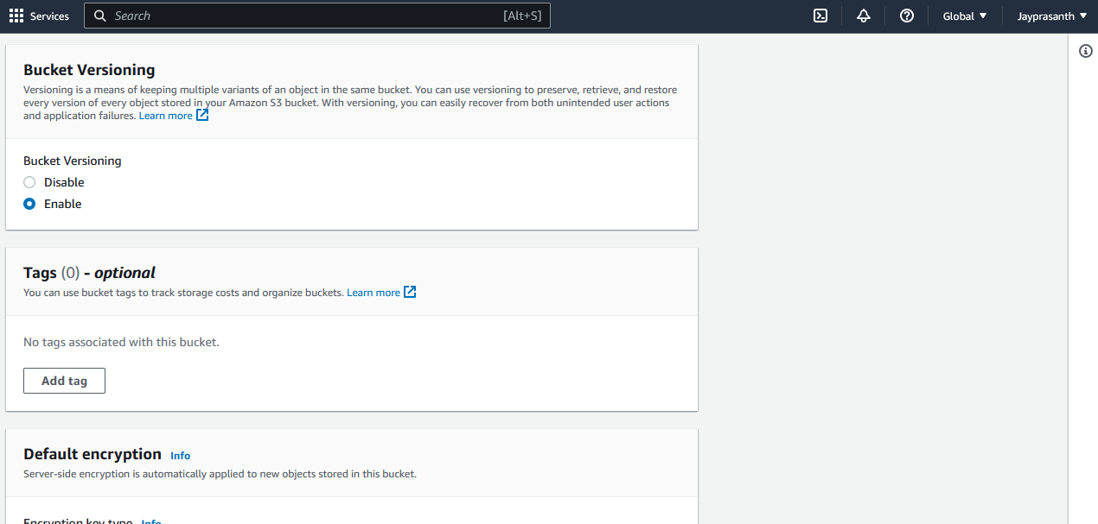

9.bucket key to disable

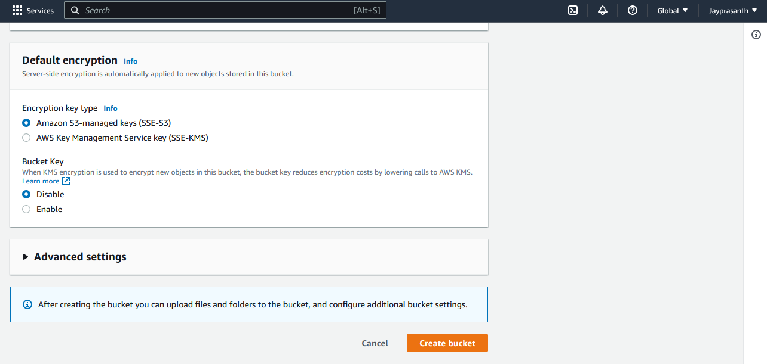

10.in advanced setting, Object also can lock but once we click enable, it's like pendrive supporting file is encrypted

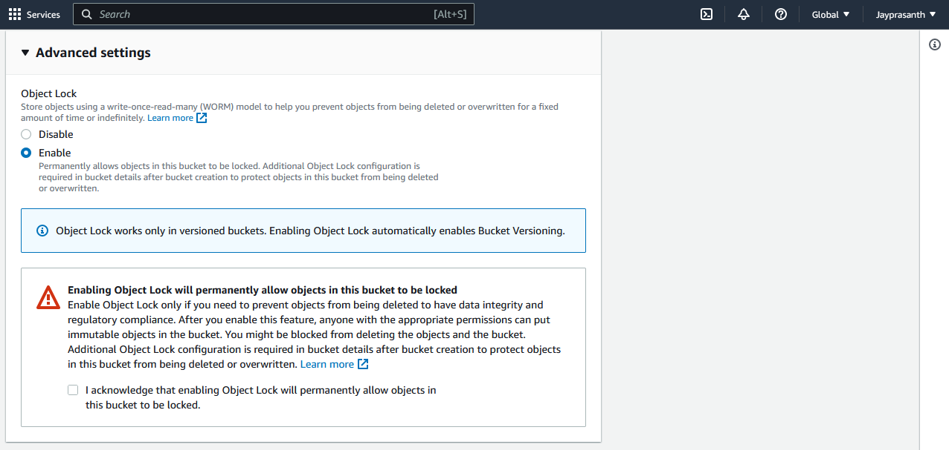

11.after finish, then click create bucket

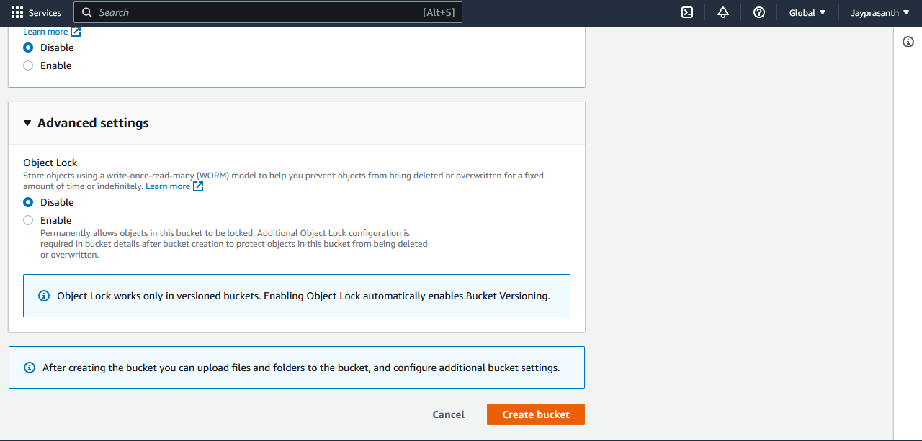

12.successfull and jayprasanth bucket is created

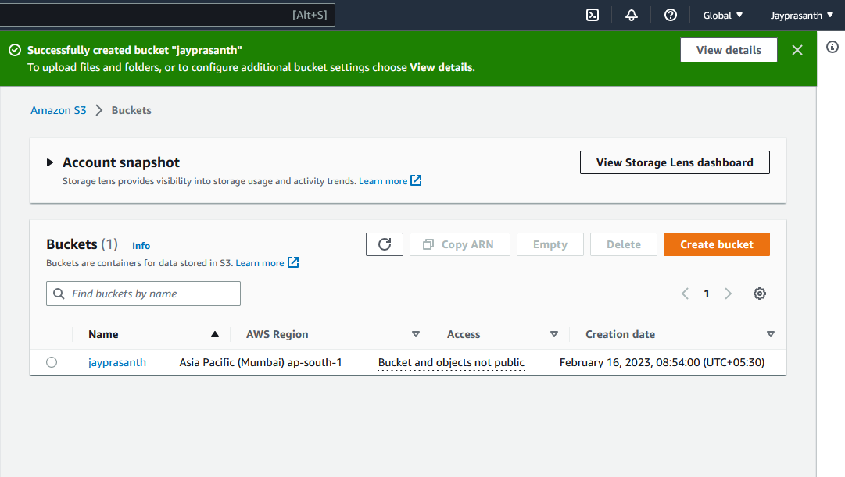

13. Click the bucket and this window shows, click upload

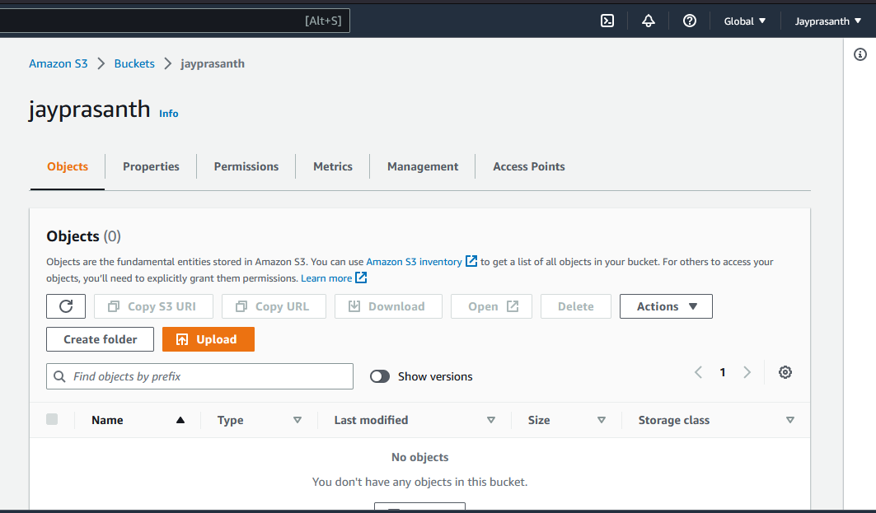

14.upload page, and click add files and choose

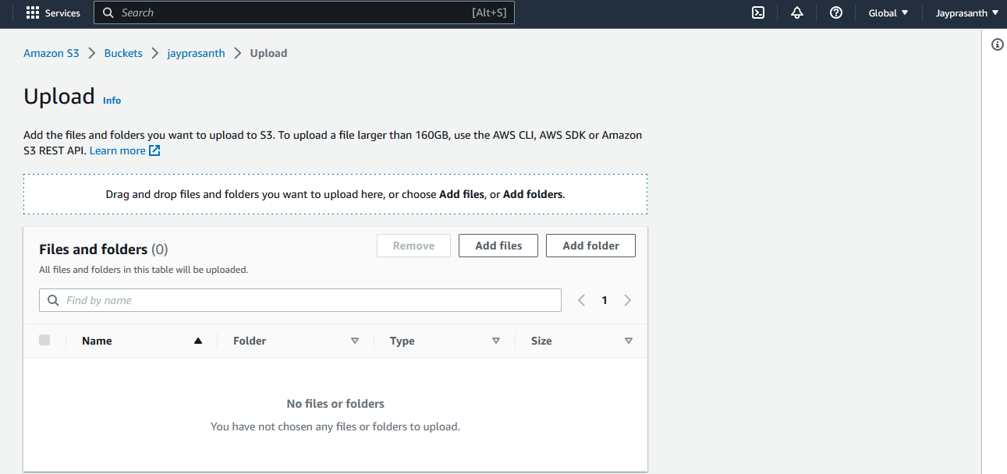

15.uploaded

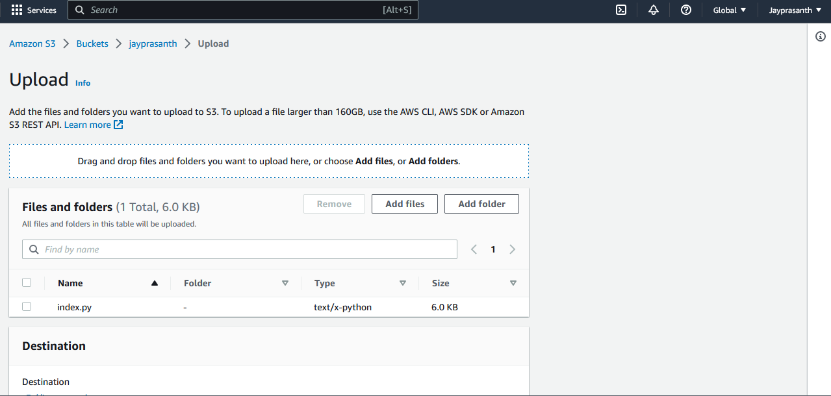

16.destination shows only s3://object name, then click upload

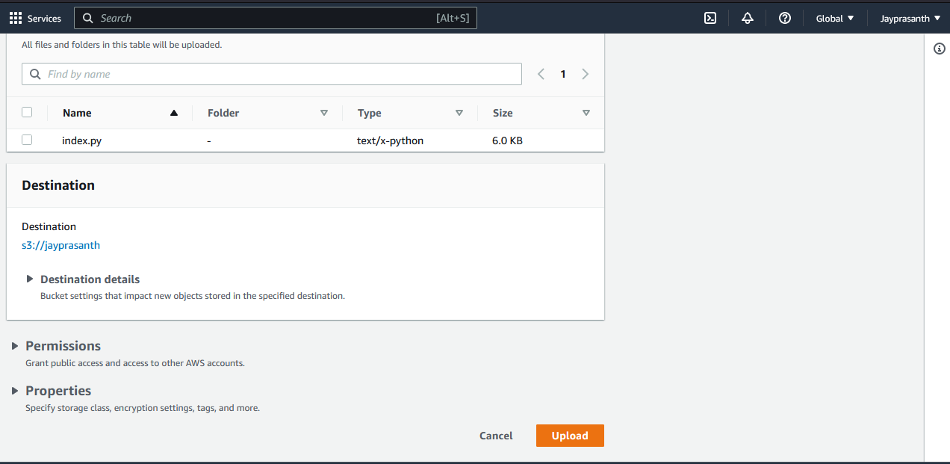

17.uploaded successfully

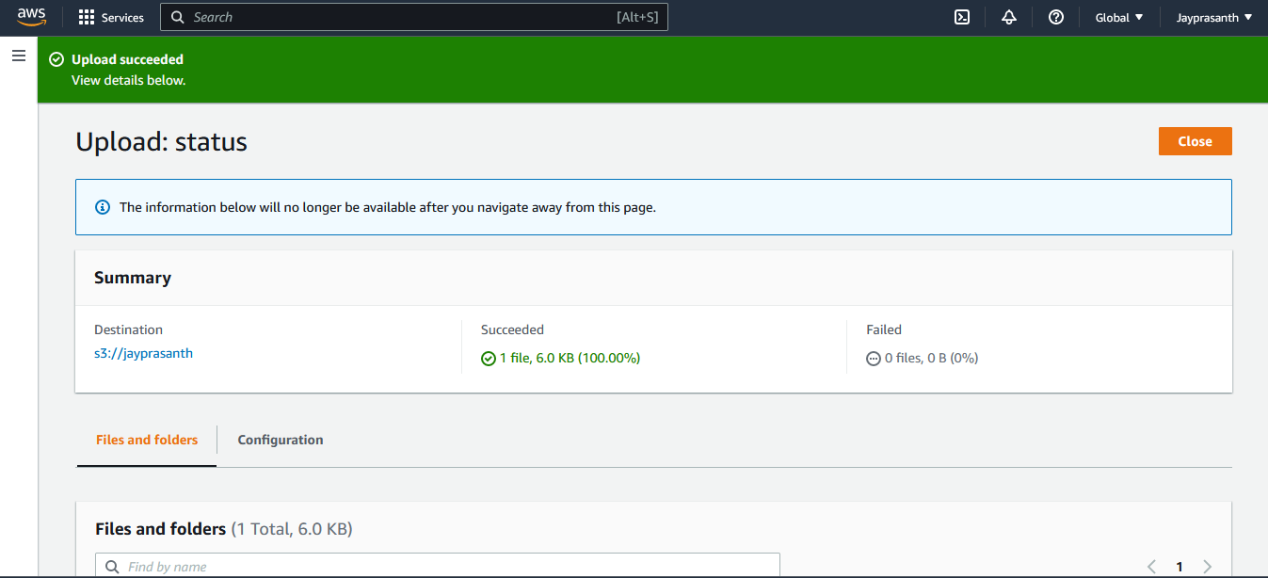

18.

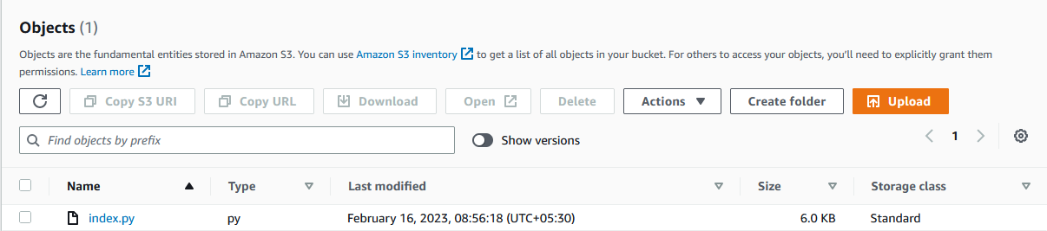

19.this page clicking of object

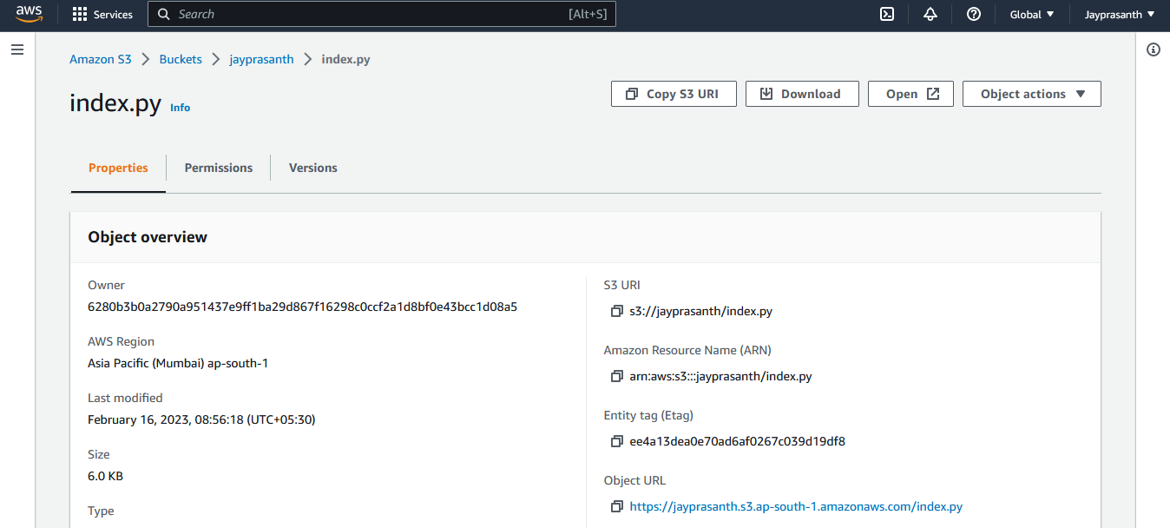

20. Again upload the same file

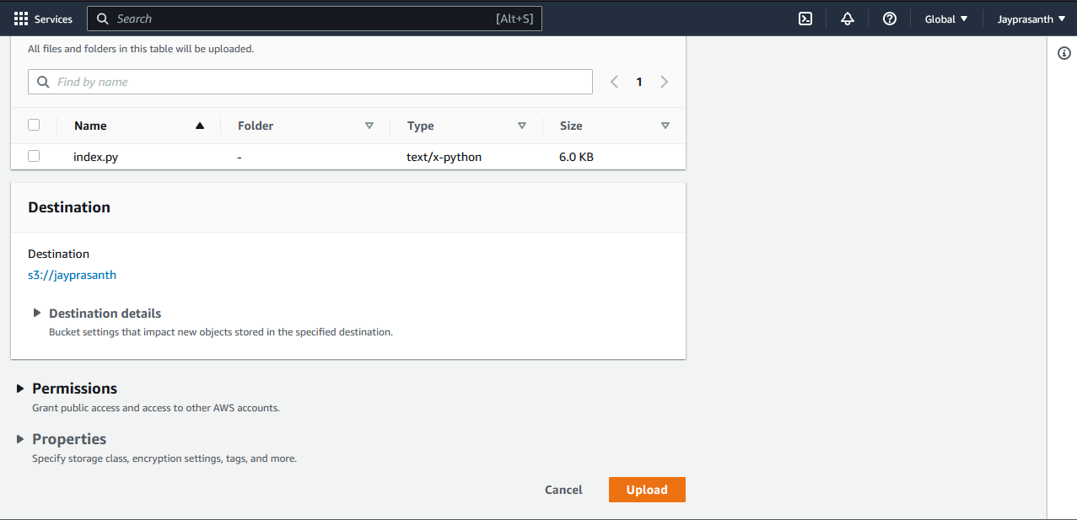

21. And click show version to see the versioning of object

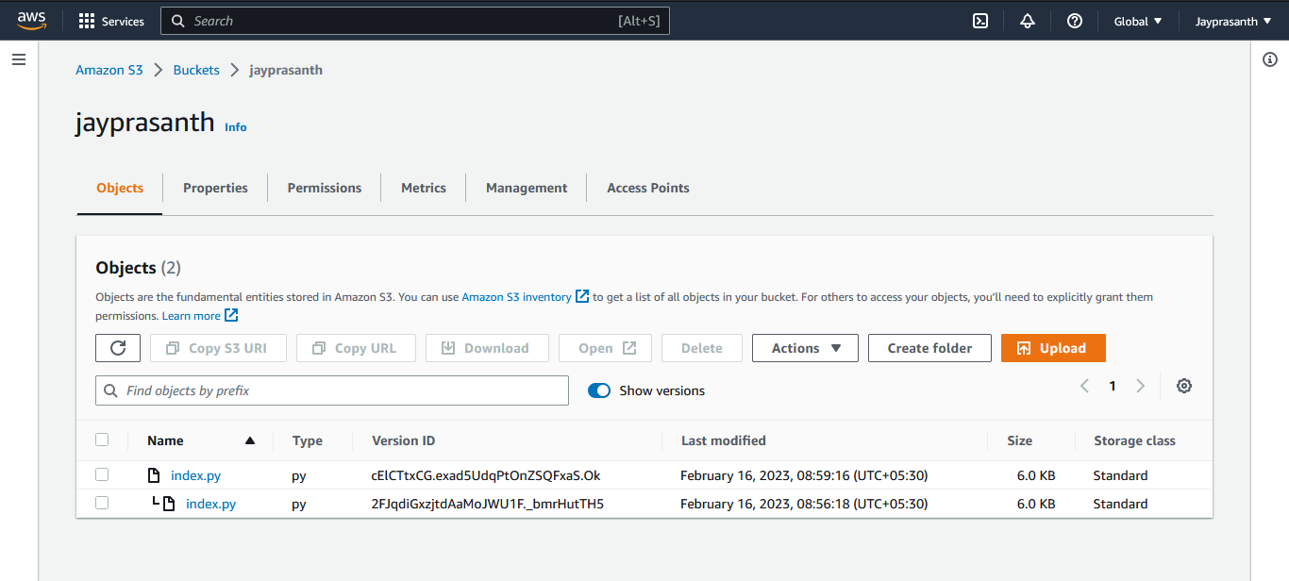

22.

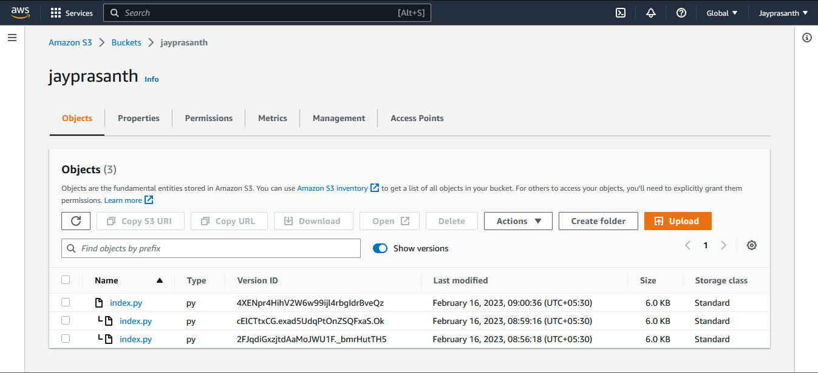

23.select all to delete and click delete

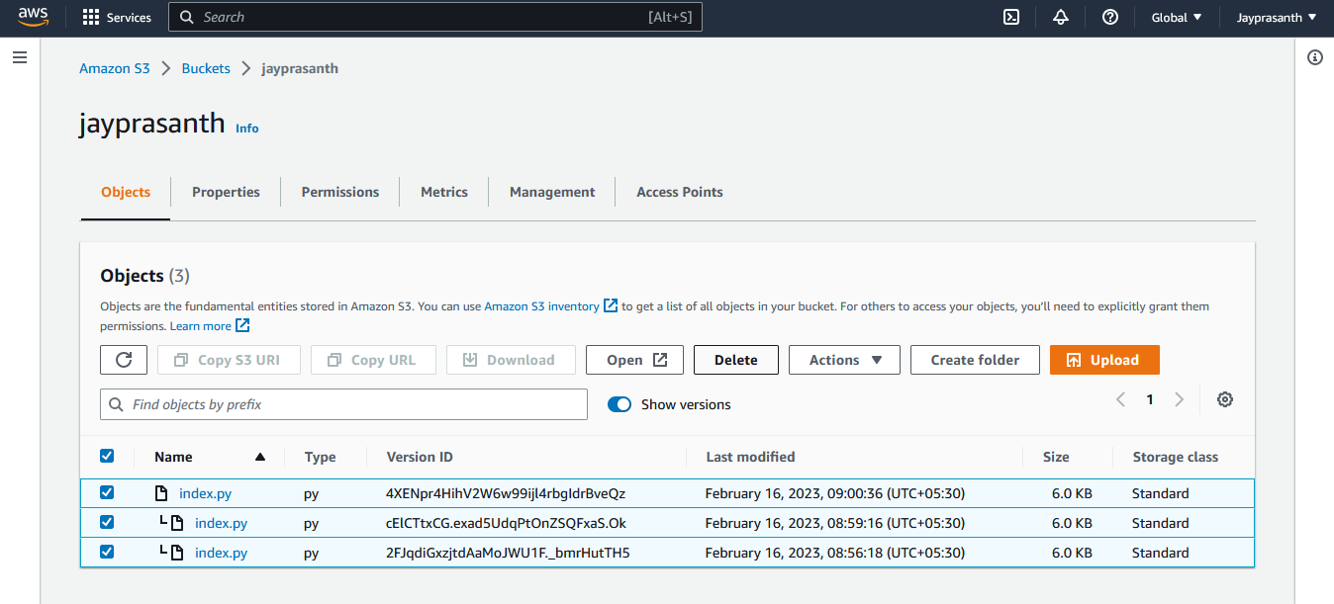

24.permanently delete

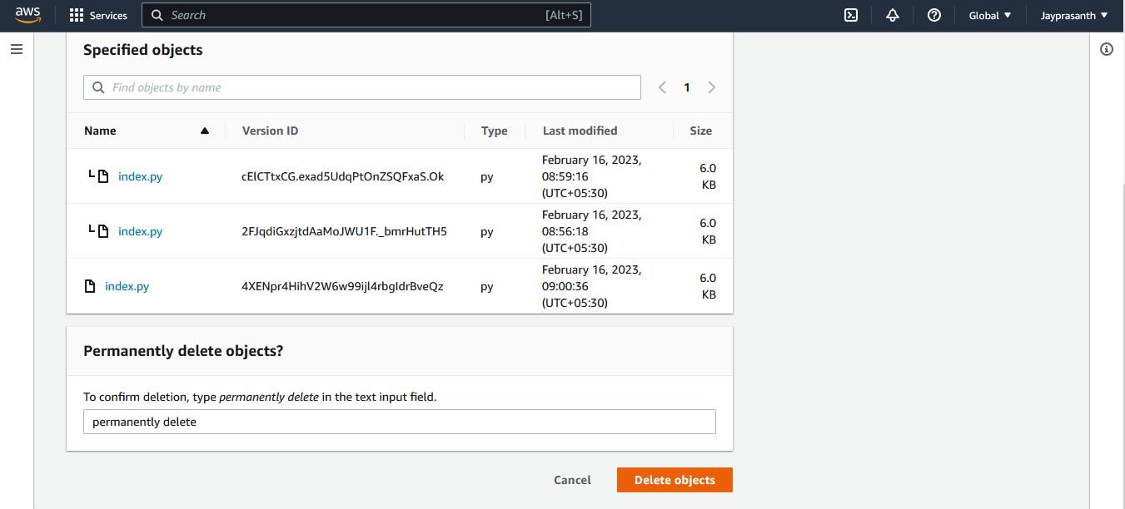

25.deleted, but if you delete old version of object I store in delete marker, then you delete the delete marker will not retrieve

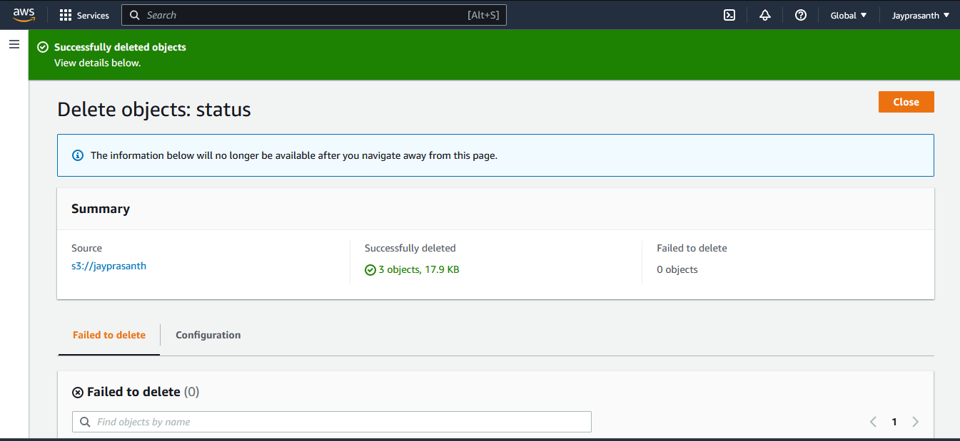

26.after deleting objects, select bucket and click delete

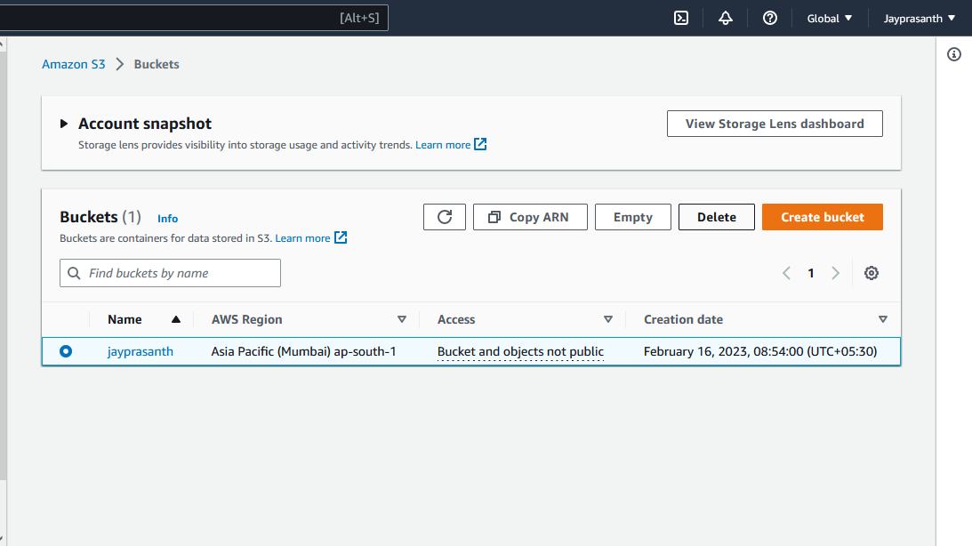

27.type name of the object and click delete

